Female Reproductive System
Earliest stages of Oocyte
- Oogonia
  - Earliest stage is Oogonia; diploid (46 Chromosomes)
  - First division into Primary Oocyte
- Primary Oocyte
  - Still Diploid
  - First meiotic division occurs during 3rd fetal month
    - Isn’t completed until a few hours before ovulation begins;
  - Secondary Oocyte
    - Forms Oocyte and First Polar body
- Secondary Oocyte
  - Undergoes second meiotic division ONLY during fertilization

Ovary
- Follicles What surrounds the ovary
  - Primordial follicles
    - Develop during fetal life
    - Consist of primary oocyte in prophase of 1st meiotic division surrounded by one later of flattened follicular cells
    - Many priomordial follicles degenate at this stage in a process called atresia
    - Few follicular cells; release estrogen
      - Become more numerous in every stage until corpus luteum

  - Primary follicles
    - Multiple layers of follicular cells develop and are called granulosa cells
      - Zona Pellucida is made of glycoproteins and forms between oocyte and granulosa cells

      - At puberty under influence of FSH, some primordial follicles mature (“Unilaminar Primary Follicles”)
      - Oocyte still in prophase of 1st meiosis (Prophase 1)
      - Stromal fibroblasts proliferate and differentiate into theca cells

    - Multilaminar Primary Follicle
      - Multiple layers of granulosa cells
      - Prominent Zona Pellucida
      - Theca interna cells developing from stromal fibroblasts
        - Stromal cells: Cells around the oocyte

  - Secondary (Antral) follicles
    - Oocyte still in prophase 1
    - Follicular fluid containing estrogen and precursors accumulate b/w granulosa cells forming antrums
      - Spaces b/w granulosa cells
      - Contain “Follicular fluid”
    - Stromal cells differentiate into theca interna and external cells
      - Theca internal cells
        - Produce estrogen precursors
      - Theca external cells
        - Protective cells composed of smooth muscle cells and fibroblasts
    - Thick Zona pellucida

  - Mature (Graafian/Vesicular) Follicle
    - Cumulus Oophorus
      - Pedestal of granulosa cells oocyte sits on
    - Corona radiata
      - Granulosa cells stick to the oocyte forming a crown
    - Antrum is symmetrical
    - LH surge signals final maturation
      - Resumption of meiosis to form secondary Oocyte
        - Arrested at metaphase 2 until fertilization

  - Corpus luteum
    - Post-release of oocyte/ovulation
      - Granulosa cells and theca interna cells turn into temporary endocrine organ called corpus luteum
    - LH from Anterior Pituitary causes
      - Granulosa cells to differentiate into granulosa lutein cells
      - Theca internal cells Theca lutein cells
      - Both new cells produce progesterone and estrogen
    - Helps maintain uterine lining in the event of zygote implantation
      - Progesterone

Two Types of Corpus Luteum
- Corpus Luteum of Mens.
  - Always forms at Ovulation
  - Lasts 14 days
  - If embryo doesn’t develop, corpus albicans forms

- Corpus Luteum of Pregnancy
  - Forms shortly after implanation
  - Persists during first timester
  - Maintained by hCG produced by trophoblasts
  - Later involutes and becomes corpus albican

Ovulation
- FSH stimulates follicles to grow
- As follicles get bigger, they release more estrogen
- As estrogen peaks, it triggers the release of LH
- LH triggers ovulation
- Corpus Luteum releases progesterone, which maintains endometrium of uterus
- Corpus Luteum withers away with FSH/LH decreasing
- Cycle starts over
- Edema and collagenases weaken the ovarian follicular wall leading to rupture of ovarian surface

Menstruation
- Constriction of arteries in endometrium causes ischemia (loss of oxygen) in upper layer (Functionalis Glands)
- Bottom layer of endometrium remains viable and regenerates (Basalis Glands)
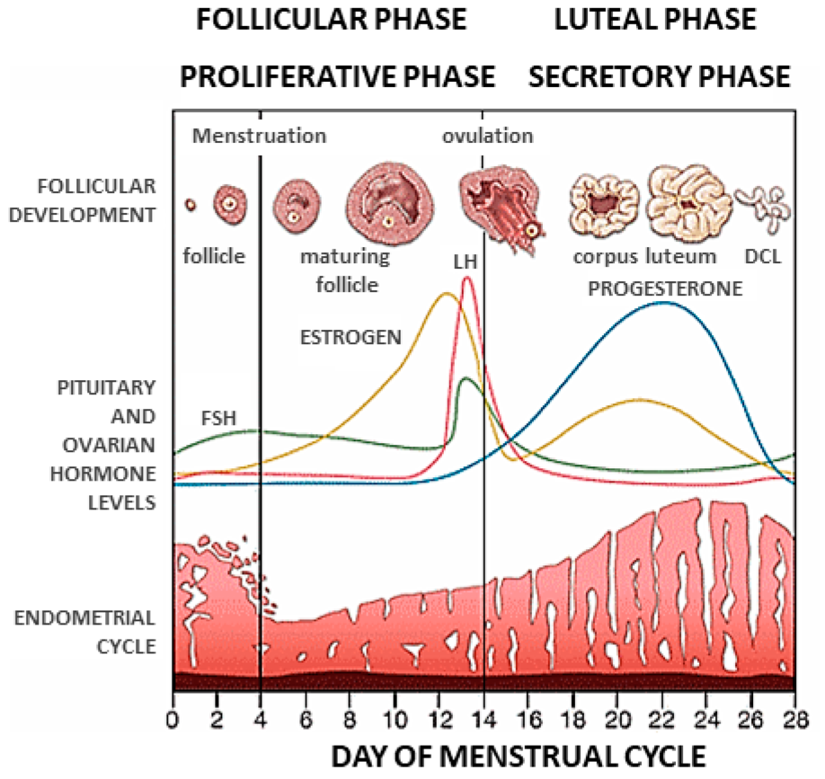

Uterus
- Layers
  - Endometrium
    - Functionalis glands
      - Sloughed during menstruation
    - Basalis glands
      - Regenerate glands after menstruation
  - Myometrium
    - Smooth muscle layer of uterine wall beneath endometrium
    - Thickens by progesterone

Proliferative Phase
- Occurs during first half of menstruation
- Glands are straight and narrow with minimal secretory activity
- FSH

Secretory (Luteal) phase
- Second half
- Glands are tortuous, wide, and filled with secretory product
- LH peaks stimulated by estrogen

Cervix
- Cervical transformation zone
  - Abrupt change from simple columnar to stratified squamous epithelium
  - In general, ectocervix is squamous and endocervix is columnar
    - Ectocervix is above endocervix; only seen in cross-sections
  - Exact location of the transformation zone changes with age
    - Transformation zone is further up in the uterus at birth, further down in young adult, and moves back in as an adult

